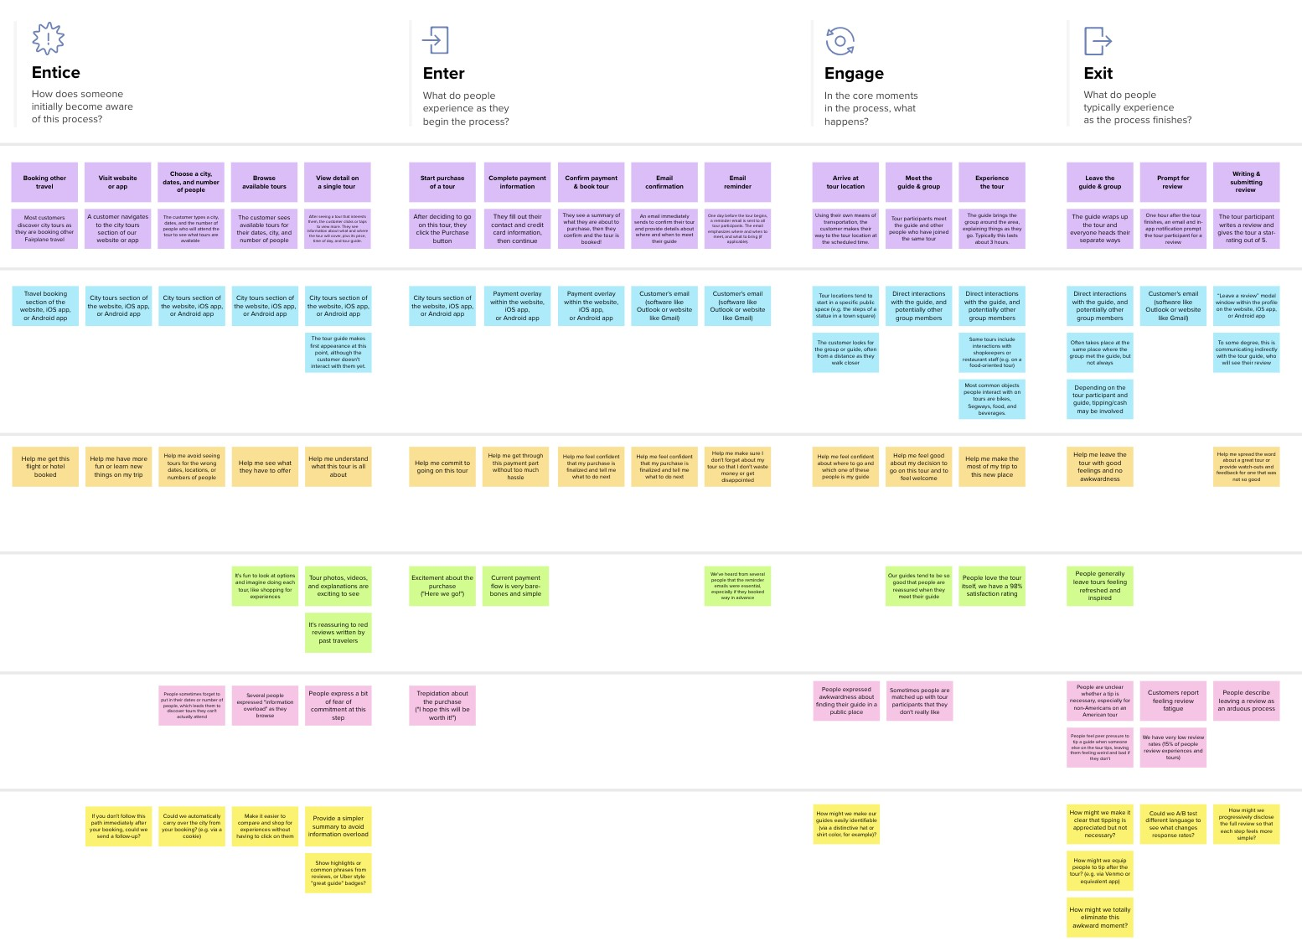

**Need some inspiration?**

See a finished version of this template to kickstart your work.

[**Open example**](https://app.mural.co/template/f59f644b-b4b4-47b5-9ed6-3a8c71ceb612/896b31fe-5597-40ef-9b06-3811a1a45ace)

[**Share template feedback**](https://muralco.typeform.com/to/CiqaHVat?typeform-source=app.mural.co)

Created in partnership with

**Customer experience journey map**

Use this framework to better understand customer needs, motivations, and obstacles by illustrating a key scenario or process from start to finish.

When possible, use this map to document and summarize interviews and observations with real people rather than relying on your hunches or assumptions.



**Template**



✴

Document an existing experience

**TIP**

As you add steps to the experience, move each these “Five Es” the left or right depending on the scenario you are documenting.

Narrow your focus to a specific scenario or process within an existing product or service. In the **Steps** row, document the step-by-step process someone typically experiences, then add detail to each of the other rows.

|  |  |  |  |  |  |
| --- | --- | --- | --- | --- | --- |
| **SCENARIO**  **Browsing, booking, attending, and rating a local city tour** | **Entice**  How does someone initially become aware of this process? | **Enter**  What do people experience as they begin the process? | **Engage**  In the core moments in the process, what happens? | **Exit**  What do people typically experience  as the process finishes? | **Extend**  What happens after the experience is over? |
| **Steps**  What does the person (or group) typically experience? | **Visit website upload image scan image**  The customer The customer has to The customer has to navigates to the upload the image if scan the handwritten uploaded section he/she has the soft digits  copy of the image | **start uploading/ Experience the**  **Scanning image output**  If the customer wants The customer will to upload the image, view the digitized he will upload it or output  else he will scan it | **After the correct Checking the image Process the image recognition of digits**  **the customer will be**  **satisfied**  Checks whether After checking the After successful recognition  customer has image, it will start of digits,the customer will  uploaded the correct processing the be satisfied, since they got  their recognized digits  handwritten image image correctly | **Leave the website**  After the correct recognition of digits, the customer will be satisfied | **Personalized Recommendation**  After experiencing our user friendly website, the customer can share information with their friends and neighbours |
| **Interactions**  What interactions do they have at each step along the way?  **People:** Who do they see or talk to?  **Places:** Where are they?  **Things:** What digital touchpoints or physical objects would they use? | **Upload image**  **section of the Scan image section**  **website of the website**  **Digitized output section of the website** | **Upload or scan**  **image section of the Output section website** | **Pop up message of Output section of website website** | **Interaction with the banker** | **Recommendation span across website** |
| **Goals & motivations**  At each step, what is a person’s primary goal or motivation? (“Help me...” or “Help me avoid...”) | **Help me to avoid Help me to find the Help me to identify wrong recognition**  **right website handwritten digits of handwritten**  **digits** | **Help me to upload Help me to**  **or scan the image recognize the digits** | **Help me to check Help me to feel**  **whether the confident about**  **uploaded image is recognized digits correct or not** | **Help me leave the website with good feelings and satisfaction** | **Help me to suggest others to make use of the website** |
| **Positive moments**  What steps does a typical person find enjoyable, productive, fun, motivating, delightful, or exciting? | **It's excites when the It's productive when digits are the digits are**  **recognized correctly recognized fastly** | **Excitement for digit It's very essential to recognition get correct**  **recognition of digit** | **This application We get a**  **tends to be good, satisfaction feeling**  **since the digits are after getting correct recognized correctly result** | **People while leaving the application feels delighted** | **We think people like these recommendations because they are satisfied** |
| **Negative moments**  What steps does a typical person find frustrating, confusing, angering, costly, or time-consuming? | **People sometimes People express a bit**  **upload wrong of fear of digits to People may upload**  **images be recognized the blurred images**  **correctly** | **People may upload the blurred images** | **Some people are People feel peer unclear while pressure while the**  **uploading/scanning image is being the images processed** |  |  |
| **Areas of opportunity**  How might we make each step better? What ideas do we have? What have others suggested? | **Could we get a error Could we get a message when message when the wrong images images is**  **uploaded recognized correctly** | **Could we get a image what we uploaded** | **Could we get any help during the process** | **Can we get history of recognized digits** | **How might we know that the customer feels good and satisfied ?** |

|  |  |  |  |  |  |  |  |  |
| --- | --- | --- | --- | --- | --- | --- | --- | --- |
|  |  |  |  |  |  |  |  |  |
|  |  |  |  | |  |  |  |  |